H.T No
Regulations:
A19

Sreenidhi Institute of Science and Technology
(An Autonomous Institution)
Code No: 7W102 Date: 20-April-2022 (FN)

M.Tech I-Year I-Semester External Examination, April/May - 2022 (Regular/Supplementary)
ADVANCED FINITE ELEMENT ANALYSIS (CADCAM)

Time: 3 Hours Max.Marks:70

Note: a) No additional answer sheets will be provided.
b) All sub-parts of a question must be answered at one place only, otherwise it will not be valued.
c) Missing data can be assumed suitably.

ANSWER ANY FIVE QUESTIONS. EACH QUESTION CARRIES 14 MARKS.

Bloom's Cognitive Levels of Learning (BCLL)
Remember | L1 | Apply | L3 | Evaluate | L5
Understand | L2 | Analyze | L4 | Create | L6

 |  |  | BCLL | CO(s) | Marks
1. | a) | Find the Eigen values and Eigen vectors of the following matrix using the Jacobi method  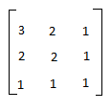 | L5 | CO1 | [7M]
 | b) | Explain briefly Runga Kutta method and Finite difference method. | L3 | CO1 | [7M]
2. | a) | Derive Transformation matrix (with neat figure) and element stiffness matrix for a Truss element. | L4 | CO2 | [7M]
 | b) | Consider the bar shown in fig. an axial load P=200x10 ³ N is applied as shown. Determine the nodal displacements in each material.  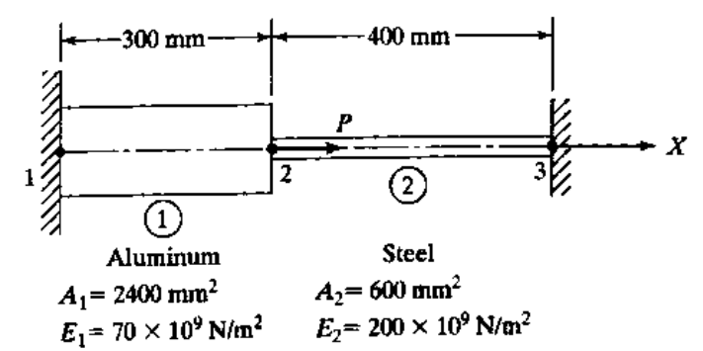 | L4 | CO2 | [7M]
3. |  | The quadratic of the node 1,2,3, of a triangular element are (1,1) , (7,3) , and (2,6) in mm. The displacement at the nodes are u₁=1 mm, u₂= 2 mm, u₃= -3mm, v₁= -3mm v₂=2mm , v₃= 5mm. Obtain the strain-displacement matrix B and determine strains ɛ_{x} , ɛ_{y} , γ_{xy}. | L4 | CO3 | [14M]
4. | a) | Evaluate eigen values and eigen vectors for a cantilever beam of length 1 m, supported at the other end. Take E = 200GPa, I = 40 × 10 ⁻¹⁰ m⁴, A = 2 × 10⁻⁴ m² and weight density = 7850 kg/m³. Use one element method | L5 | CO4 | [7M]
 | b) | Evaluate nodal frequency of the beam shown in below figure. Use two element model and take E=210 GPa, weight density 7800 kg/m³, A=400 mm², and I = 5000 mm⁴.  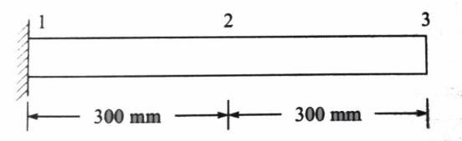 | L5 | CO4 | [7M]
5. | a) | Write the application for the finite element analysis for thermal problems. | L1 | CO5 | [7M]
 | b) | Estimate the temperature distribution in 1-D fin as shown in the figure by making the fin In to two elements.  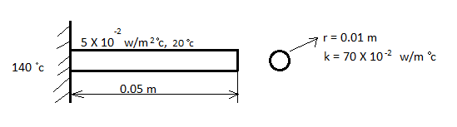 | L5 | CO5 | [7M]
6. | a) | For the one-dimensional flow through the porus medium shown in below figure with fluid flux at the right end, determine the potentials at one-third and two-thirds of the length. Also determine the velocities in each element. Take A=2m²  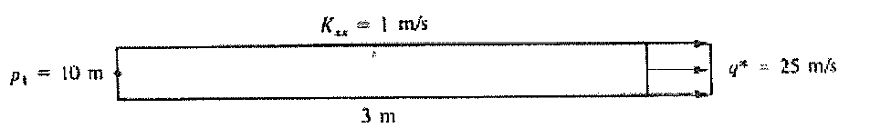 | L4 | CO6 | [7M]
 | b) | Formulate step by step the stream function for inviscid and incompressible flows. | L3 | CO6 | [7M]
7. | a) | Explain the equilibrium state of the system, when the system is subjected to different types of loads and explain the stress and equilibrium relations. | L2 | CO1 | [5M]
 | b) | Find the deflection at the load at the ends for the steel shaft shown in figure. Consider the shaft to be simply supported at bearings A and B.  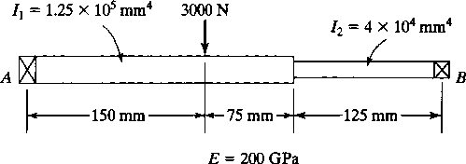 | L5 | CO2 | [5M]
 | c) | Explain in detail finite element analysis of plates in bending. | L2 | CO3 | [4M]
8. | a) | Heat is generated in a large plate (k=0.8W/m ºC) at the rate of 4000 W/m³. The plate is 25cm thick. The outside surface of the plate are exposed to ambient air at 30⁰ C with a convective heat transfer co-efficient of 20W/m² C. Determine the temperature distribution in the wall. | L4 | CO5 | [7M]
 | b) | Give step by step formulation about Potential function. | L4 | CO6 | [7M]

-- 00 -- 00 –

